To: John Pepper,

Subject: Submission proposal to create disabled friendly one mainstream school in Kathmandu.

Dear Sir,
Thank you for your kind interest in our project Akshar Arambha Nepal. I remember the first time introduction with you by Teh Francis (Cameroon), through the Face book and I had shared my project idea with you. Rather I pleased meeting you at my place in Kathmandu.
Akshar Arambha Nepal is a small organization started after training in kanthari institute India (empowers social visionaries across the world) and has been active in creating disabled friendly mainstream schools and motivates children with disabilities in an education. We work for children with disabilities inclusive education in government schools in Kathmandu. We believe all children born with potential and can learn and progress together exchanging their idea and creativity. For this we promote inclusive education where disabled and nondisabled children can play together, learn together, go to school joining hand in hand and singing a song of education for all. We are submitting herewith proposal “Creating disabled friendly mainstream school in Kathmandu”. As a founder I have good experience in inclusive education and project management with 15 years’ experience. I humbly request you go through herewith the detail proposal. And consider with positive response soon.
Sincerely yours

Lila Nath Pahadi
Founder/President
Akshar Arambha Nepal
We promote inclusive education in Nepal
June 22, 2018

Name of the Social Venture: Akshar Arambha Nepal
Project Title |  | Creating disabled friendly mainstream school in Kathmandu.
 | Name of the Applicant | Akshar Arambha Nepal  Tel.: +977-9860689718 Nepal  E-mail: founder@aa-nepal.org /lila2016@iiseconnect.org  Skype: lilanathpahadi  Website: www.aa-nepal.org
Project location: |  | Kathmandu, Nepal
Project goal |  | Promoting children with disabilities through inclusive education.
Responsible person: |  | Lila Nath Pahadi, Founder/President

Executive summary
A Sabina Bhattari daughter of father Narayan Bhattari and mother Kanchhi Bhattari origin of Jiling 8, Nuwakot. Sabina is12 years old and reads in class 5. She is in wheelchair. Though she enrolled in Kanti Bhairab School but school did not have disabled friendly environment. She was feeling difficulty everywhere i.e. toilet, sitting arrangement at classroom, discriminated by friends and teachers etc. All of these activities posed her to dropout time and again.
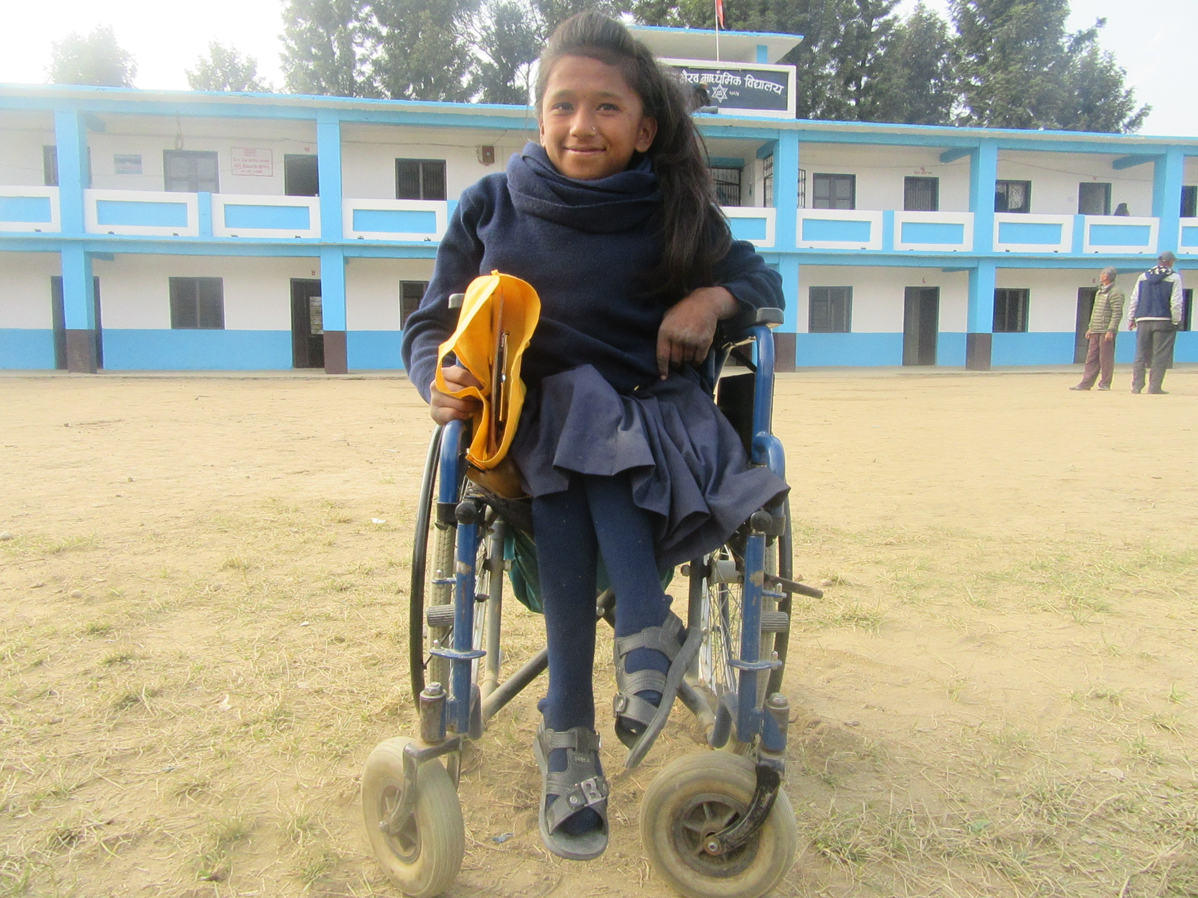
In this situation we (AAN) intervened at school and modified existing toilet with commode, spray pipe, grabber handle, disabled friendly door and wheelchair round space inside the toilet, disabled friendly chair at classroom for her comfort sitting at classroom, teacher training and speech competition about importance of inclusive education, disability and education among the school students. All above activities played significant role to feel her comfortable at school. She passed her grade 5 with good marks and happy at grade 6. She wants to give many thanks for Akshar Arambha Nepal-AAN and ask us to come at school continuously to monitor their education environment to vibes positive impact continuously.
Our organization Akshar Arambha Nepal plans to create one models of inclusive school in Kathmandu which will be accessible and disabled friendly. To convince the government and many other mainstream schools to open their doors for disabled students. We envision a school where disabled and non-disabled students can play and learn together and go to school hand in hand without any hesitation and barriers (see details in solution and action plan). To complete this project we have estimated budget £9,970.

Our (AAN) path

Akshar Arambha Nepal-AAN is legally registered (registration no. 165224/073/074) nongovernmental organization (NGO) under the institution enrollment act of Nepal. It is a national organization to promote inclusive education for children with disabilities through campaign, advocacy, lobby and networking with the common interest groups in Nepal. We also provide vocational education for those who are out of school or never got the opportunity of school or college education.
As the nongovernmental and non-profitable organization AAN has been proactively working in education rights of persons with disabilities in Nepal since 2016 through its working strategies-advocacy, awareness raising campaign, networking with interest groups and collaboration.

Over the past 2 years, Akshar Arambha Nepal achieved several goals.
-We have formed 5 members one inclusive education consultation discussion forum.
-We have two disability self-help groups with local resource mobilization necessary skills.
-We able to enroll 31 physically and 1 low vision disabled children in the mainstream school.
-We printed 1500 brochures in which the importance of inclusive education was explained.
That significantly helped us in inclusive education local campaign. The goal of the campaign was to create awareness and to motivate the parents to have their disabled children enrolled into regular schools. Through this campaign we were able to enroll 32 disabled students in the school. For continuation of their school education we have modified school infrastructure to build least restrictive environment in school. i.e. especially in toilet commode, spray pipe and grabber handle for disability access, accessible chairs for disabled student in the classroom; speech competition, essay, article and story writing about disability and inclusive education, training for teachers to reduce bullying in the school. We are also processing to build 10 feet height and 120 feet length ramp in the school collaborating with NFD-N (a local NGO).

Problem definition
- Disability and education
WHO defines, disability is an umbrella term including impairment, activity limitation and participation restriction. The term, impairment is a problem in body function or structure; an activity limitation is a difficulty encountered by an individual in executing a task or action; while a participation restriction is a problem experienced by an individual in involvement in life situations. Disability is thus not just a health problem. But in our society, disability use to view as pity, object of charity and illness.
As we know UNCRPD has accepted that education is a fundamental human right but a right that is denied to over 70 million children in the world and one third of those are children with disabilities link. Report adds most of them are in underdeveloped countries like Nepal. “Living Condition of Disabilities in Nepal” research report in 2016 by National Federation of the Disable Nepal” states there are 179,000 children with disabilities in between 05-18 years in Nepal; among them more than 60% are not in school. Moreover there is a lack of early intervention, rehabilitation facilities and other special support which they should be entitled to. Many face infrastructural barriers, social discrimination, ill treatment and rejection by their own families, teachers and peers.
Children with disabilities in Kathmandu
As per the latest Census Bureau of Statics Report, 2011: 17122 people with disability in Kathmandu. Unfortunately the data is not segregated or analyzed based on age groups.
Number of disabled persons enrolled in:
- 326 Early childhood development classes: 0 enrolled out of 17122 disabled children
- 883 Basic level schools up to class 8: 39 children with disabilities out of 58752 students
- 279 higher secondary schools (class 9-12): 0 out of 49151 students.
It shows mostly children with disabilities do not go to school. Those who are in school do not continue their education till secondary or higher secondary level. On the other hand two years back divesting had massively destroyed houses and schools in Kathmandu. Many children with disabilities have already been deprived by education and now the situation even more difficult. Root causes of these hindrances are lack of access, schools are not equipped and teachers are not adequately trained. The teaching procedures in mainstream schools are not appropriate to include children with disabilities. Also the attitude of teachers, management, parents and local education promoters need to improve. Many don't believe that disabled children can learn and progress like nondisabled children. In addition, children with disabilities face discrimination and humiliation from their fellow students. Even though, the Nepal government has released the “Public Building Code, 2012” which declares that all public buildings and places should be accessible for all, most public schools and many other buildings are still not disabled friendly. As consequence children with disabilities are not enrolled in schools and those who are; do not complete their secondary level. This leads to illiteracy, unemployment, exclusion and in the end to poverty.
- Failure practice to bridge the gap
Since the year 2000, the Nepal government has been trying to implement “Education for All” project. For this, it has taken support from UNESCO, UNICEF, UNDP, and the World Bank, ADB, DANIDA, USAID, JAICA and many more. But the impact has not been visible in main stream schools. This Education for all project has not address adequately students with disabilities issues in schools. So the problem has been occurring. Like accessibility, equity in classroom involvement, teacher, school managements behavior towards student with disabilities, parents awareness program etc. In Kathmandu we can also find some children homes and has been working for disabilities education in small number. This type of trial project promotes parents to give up their responsibilities towards their children with disabilities to non-governmental organizations like NGO. Institutionalization of children with disabilities is not good for friendship, family environment, with other nondisabled children in mainstream school. This hinders their future endeavor. Further drawbacks: these types of special schools are limited in number and located in particular city. If small children go far from their family they missed not only love of their parents but also guidance and family environment. Beside of those children with disabilities, especially from illiterate and poor families would never have access to central residential especial schools and they won't see the relevance of education at all. Due to all facts that are mentioned above, there is obvious need of inclusive education program to enroll children with disabilities in their neighborhood schools.

Detail strategies to solve the problem
- Vision statement of the project
We envision Kathmandu as a district, known for successful integration of children with disabilities in school who play and live with non-disabled in unity and go to school hand-in-hand with their non-disabled friends, singing a song of education for all in 1 year in one school catchment area. Schools are known as a miniature society; once we able to build one inclusive school than we can dimensions in society at large. For this, we have a project “creating disabled friendly one mainstream school in Kathmandu” pilot for 1 year. This project will support to create open and accessible one school for children with disabilities. By the teacher training, promotion of children with disabilities to go to school, encourage their parents, society and local stakeholders to ensure access to education for children with disability in neighborhood schools.
- Advocacy and networking
To walk towards the project goal, at first we build relationship with district education office and mainstream schools. We will create a lobby and advocacy group that exists of 5 members; school management committee-SMC and parents’ teachers’ association-PTA. This consultation committee will support the project during challenges. Similarly we have planned to 1 disabled people self-help groups in project implementing ward level (local level). Each group will have 5 members. The self-help group will help project in children with disability screening in local level, advocacy and link them to local government program, support during the challenges in school, exchange, share learning experience form the best practices, link and refer children to treatment if there is possibility, search local resources and mobilize for their wellbeing like many more. Within one year, this program will benefit at least 30 children with disabilities. End of project year we organize inter disability groups conference to exchange their learning experience. We also moderate the program to compete each-other. We reward for better learning experience. That will encourage them to hard work for the betterment / winning the award. Simultaneously this conference will help to raise awareness about disability and education, bring out theirs insight in a wide level as well.
- School support program
Through the project we want to create 1 disabled friendly school environment by providing 2 days inclusive education orientation for 1 schools 10 teachers, 2 school management committee-SMC members and 2 parent’s teacher association-PTA members. The orientation program curriculum will include sessions about: what is inclusion? The word inclusion means locking in, or equal treatment in classroom? Group work and presentation, best practices form other countries, - what we are practicing in Nepal? Open group discussion in challenges, obstacles and opportunities etc. This orientation program will help trainees to develop understanding towards inclusive education. However this short term orientation program may not sufficient for schools stakeholders will not be sufficient. After this training we link trainees to resource person, school inspector, district education office-DEO and will try to connect with National Center for Educational Development-NCED to expand their knowledge on inclusive education. This program will help to create positive behavior towards children with disabilities in schools. Particularly in school enrichment, class involvement, positive attitude, support and link them to fulfill their needs. We have also planned to support 1 school notice board, teaching learning materials, 3 ramps and maintenance for 1 toilet if there is needed to restructure for disabled use. Through the notice board we want to create students writing group in each school including student with disabilities. That group will encourage their peers to write and compete to post their article, essay, poem, story etc. in about disability, disability and education, poverty and disability etc. Among the students writing team will publish top writing on notice board. That will help to create knowledge about disability, positive attitude and favorable environment for disability in school. Similarly selected school will conduct speech competition in similar subjects. That will also help to create knowledge about disability as well as student with disability friendly environment in schools. Teaching learning materials will help to support in class where disabled and non-disabled students will get extra support, those who do not cope regular class despite of teacher effort. Subject matter expert and special teacher will lead this class to make them understand the subject matter properly to come back to the regular class. This way at least 30 students with physically disabilities will be directly benefited together with their non-disabled peers by this inclusive education project. In addition ramps and accessible toilets will help to adjust student with disabilities in school. That obviously helps to continue their education.

Project goal: Promoting children with disabilities education by self-help groups and inclusive schools.
Objective: A1. Empowering and mobilizing people with disabilities for education
Objective: A2. Develop support system for children with disabilities in inclusive schools

Outcomes of the project:
- 60 Student with disabilities and their parents in Kathmandu district will have access to needful information and support system in their own village to develop their career.
- 1 mainstream school in Kathmandu will assure least restrictive environment (physical and psychological) for student with disabilities and other at least 1 school will have impressed by the accessible module school.
- Local 1 self-help groups will have empowered to develop support system for children with disabilities education in local schools, advocacy for least restrictive environment in school and also connect disabled students to government scholarship program as well.

Budget in detail
Exchange rate: 1£=143:69 NPR as per the Nepal Rastra Bank forex exchange rate in 25 Jun 2018.

S.N. | particular
 | Program cost | freq | qty | unit NPR | unit £ | total NPR | total £ | %
1 | Organize one disability consultation discussion forum @ school area | 1 | 25 | 1,500 | 10.44 | 47,500 | 330.57
2 | Creation of disability self-help group in ward level | 1 | 20 | 1,500 | 10.44 | 35,000 | 243.58
3 | One day training for self-help group for active function for their wellbeing | 1 | 5 | 1,000 | 6.96 | 10,000 | 69.59
4 | 2 days inclusive education orientation program for school teachers, SMC and PTA | 2 | 20 | 1,500 | 10.44 | 76,000 | 528.92
5 | Speech competition in school | 2 | 1 | 10,000 | 69.59 | 20,000 | 139.19
6 | Planning and review meeting (7members) | 4 | 7 | 1,500 | 10.44 | 42,000 | 292.30
7 | Processing to scholarship from district education office | 6 | 1 | 5,000 | 34.80 | 30,000 | 208.78
8 | Support teaching learning materials for 1 resource/ special classes | 1 | 1 | 50,000 | 347.97 | 50,000 | 347.97
9 | One notice board for mainstream school (Ref. local furniture house) | 1 | 1 | 30,000 | 208.78 | 30,000 | 208.78
10 | Need assessment and toilet modification for disability access (One toilet) | 1 | 1 | 100,000 | 695.94 | 100,000 | 695.94
11 | Support three 1:12 feet ramps in schools (as per need assessment) | 1 | 3 | 50,000 | 347.97 | 150,000 | 1,043.91
12 | One inter disability and self-help groups conference to exchange their learning experience | 1 | 100 | 1,000 | 6.96 | 100,000 | 695.94
16 | Program Officer salary (Full time) | 12 | 1 | 30,000 | 208.78 | 360,000 | 2,505.39
17 | Program assistant (part time) | 12 | 1 | 12,000 | 83.51 | 144,000 | 1,002.16
 | Sub total |  |  |  |  | 1,194,500 | 8,313.04 | 83.91
 | Running cost
13 | Rent for office space | 12 | 1 | 7,500 | 52.20 | 90,000 | 626.35
14 | Utilities (Electric, Internet, Telephone, Water) | 12 | 1 | 4,000 | 27.84 | 48,000 | 334.05
15 | Stationary+ maintenance | 12 | 1 | 1,200 | 8.35 | 14,400 | 100.22
 | Sub total |  |  |  |  | 152,400 | 1,060.62 | 10.7
18 | One time cost
19 | Office chairs | 1 | 2 | 5,850 | 40.71 | 11,700 | 81.43
20 | Laptop | 1 | 1 | 65,000 | 452.36 | 65,000 | 452.36
 | Sub total |  |  |  |  | 76,700 | 533.79 | 5.39
 | Total |  |  |  |  | 1,423,600 | 9,907.44

Budget Note as per the NPR cost value

- Total participants=25* transportation for each participants 500= NPR 12500, Program hall with necessary equipments i.e. mike, dashboard, speaker, projector, chairs etc. breakfast and lunch for the participants per person NPR 1000*25= NPR 25000=37500+ Stationary and banner NPR 6000+ preparation transportation and communication const NPR 4000= Total const NPR 47500
- Total participant 20* per person transportation 500= NPR 10000, Program hall with necessary equipment i.e. mike, dashboard, speaker, projector, chairs etc. breakfast and lunch for the participants per person NPR 1000*20= NPR 20000, Banner and stationary 3000, preparation transportation and communication const 2000. Total cost for program NPR 35000
- Total participants 5+1 trainer 6, per person transportation for the participants 500*6= NPR 3000, per person breakfast and lunch 500*6= NPR 3000, preparation+ stationery NPR 2000, Trainer/facilitator=NPR 2000 Total cost for the program= NPR 10000
- Total participants=18+2 trainer= 20 persons, per person transportation=500*20 persons=10000*2days=20000 + Program hall with necessary equipment i.e. mike, dashboard, speaker, projector, chairs etc. breakfast and lunch for the participants per person NPR 1000*20= 20000*2days= NPR 40000+ per day honorarium for trainer 3000*2 days=6000 + stationary and banner 5000+ Preparation transportation and communication 5000= Total cost for the program= 76000
- Total program participants in the hall about 200, 1st 2nd and 3rd prize in order to 2000, 1200 and 800=4000, Tea and snacks for the teachers, students participants 6000=10000*2 programs=NPR 20000
- Quarterly Review and Planning Meeting with the board and staff Per person transportation=500*7 participants=3500, per person tea, breakfast and lunch 1000*7=7000=10500*4 times=42,000
- Transportation and lunch for the meeting with class teacher and district education office, per meeting cost 5000*6 times in a year = NPR 30000
- Teaching learning materials for resource class 1 desktop assembled computer 25000, Cannon 3 in 1 printer 22000+ chart paper and marker 3000= NPR 50,000
10) As per the school toilet situation, access analysis and user group feedback we can invest up to one hundred thousand for disability access in sch.
11) As per the school accessibility audit and analysis by the disability expert we can build up to 3 small curve ramps that paid up 150 thousands.

12) Learning experience exchange: program hall with necessary equipment i.e. mike, dashboard, speaker, projector, chairs etc. + breakfast and lunch for the participants per person NPR 1000*80=80000+ stationary and banner 5000 + gift for the 1st,2500, 2nd 1500 and 3rd 1000+ welcome shawl, flower and other necessary things 5000+ Arrangement transportation and communication 5000= NPR 100000

